Celestina Billington
Thursday, July 27, 2017

DJs Dish on Best Late-night Eats in HOU

Let’s open with a recent study from Penn Medicine, titled “Eating Less During Late Night Hours May Stave off Some Effects of Sleep Deprivation.”
My retort? Good! Now my friends in the bartending industry will finally stop spending their rent money on cocaine. (Who knew that all you needed to stay awake was a steaming slice of pizza?) The money being siphoned to border cartels can finally make its way back to where it belongs: flourishing through small businesses that never close. Truly, there is nothing quite like making it rain on a waitress working less than minimum-wage at three AM. She won’t give you a lap dance, but things will get steamy. And in Houston, Texas, there’s no limit to your culinary options, no matter the hour. From tacos al pastor, to kung-pao tofu, if there’s one thing the free-market is good for, this is it and it is lit. So for this article with FreePressHouston, I consulted our city’s reigning experts on the joys of insomnia: DJs. From the dance-floor to the kitchen table, these folks know how to have a good time. Here’s what they recommend.

CHAPULTEPEC LUPITA
This 24/7 mom-and-pop shop offers over 60 options of tequila, so it’s no surprise that both synth-pop princess Tee Vee and techno-punk charmer Josiah Gabriel suggested it. Forever true to their respective aesthetics, their menu choices held surprising parallels to the music they make. Tee Vee revealed that she typically orders the vegetarian Chimichanga, a deep fried burrito topped with chile con queso. Like Tee Vee’s music, the Chimichanga is fun and satisfying.

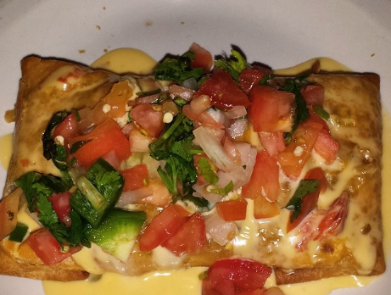
(Caption: What tastes good when you’re drunk aint cute)

On the opposite end of the spectrum, you have Josiah Gabriel (i.e. Noah Daniel Clough). He orders the Chile Relleno, a stuffed and grilled Poblano pepper. And since that’s not spicy enough for his tastes, he compliments the dish by adding raw green chili peppers. Which means his eats are like his beats: hot yet uncomfortable. I can only wonder at and admire this kind of pepto-abysmal quality in such a man.
Chapultepec Lupita is located at 813 Richmond Avenue, 77006.

WHATABURGER
Before the foodies in the crowd take their jabs at this fine establishment, I would challenge them to think of a more affordable and accessible option. There’s a reason Houston locals have written odes and verses commending their fine menu. Amongst the artists who’ve immortalized the fast-food chain is rapper and DJ Anthony Obi, AKA Fat Tony. He even has a whole line of shirts and hats that utilize the famous orange triangle, and titles them “Whatatony.”

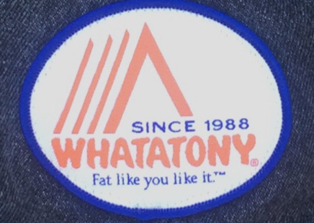
(Caption: We do indeed like it.)

But the appreciation doesn’t end there. One of his most popular music videos, Drive-Thru, features the Whataburger at Houston’s Shepherd Dr. location in multiple shots. We mostly see Fat Tony and his crew munch on French fries and sip sodas in the video, though, so I probed him to find out what he usually orders.
“I enjoy the potato taquito with an order of fries or onion rings. Seven spicy ketchups and five packets of salsa are necessary to make this meal POP OFF. Condiments are King. Don’t play yourself.”
The Whataburger from “Drive Thru,” can be found at 3624 Old Spanish Trail, Houston, TX 77021

THEOS
Following a sabbatical of sorts in Brooklyn, New York, Brynn Juniper has made her triumphant return to Houston’s queer music scene. A fab trans-girl, she’s no stranger to shitty comments from shitty people. In our discussion about where to go for a bite after midnight in Houston, Brynn first shared an eye-opening experience about House of Pies, “This one time I was there with my girlfriend and we were sitting next to each other in a booth and our waiter told us […] that ‘people are complaining.’” Fortunately, that hasn’t been her experience at local Greek-fare restaurant Theos, “The people there set such a groovy vibe and they play dope music I never get to hear elsewhere.” Brynn informed me that she orders the Veggie Platter. The meal comes with an assortment of grilled vegetables and is served with lemon potatoes, spanakopita and tiropita. Located in the heart of Houston’s Montrose, this is a great spot to head to after a late night dancing at Numbers or Avant Garden.
Theos is situated at 812 Westheimer Rd 77006
(Caption: OPA? More like O-PAPI.)

MAIS
Who doesn’t love a midnight binge snack? That is exactly what you will be tempted for if you find yourself anywhere near this Vietnamese establishment in the wee hours. With a whole host of options for people on any kind of diet—gluten free, sugar free, vegan, or downright carnivorous—Mais has something for everybody. Visual DJ Taylor Knapps, who goes by Sppanksvisuals on Instagram, divulged about an interaction with a waitress there.
“I wanted to get the Pad Thai there, so we ordered it. But the waitress told us, ‘there are no returns on that,’ and I never thought of returning the food. She said [that she warned him] because it’s ‘straight-up Asian food,’ and I was like, ‘Ok...’”
Fat Tony also mentioned Mais in his interview, and noted that he’s a fan of the Garlic Tofu and Lemongrass Tofu. Other popular options at Mais include spring rolls, fried rice, and Pho.
Mais is open until 3 am during the week, and 4am Friday—Saturday. Sadly, they’re closed on Sundays. 3403 Milam St. 77002

(Caption: You “mais” eat way too much here #noregrets)

It’s time to face the music: if you’ve read this far, you have no respect for your sleep schedule. But who doesn’t love a midnight binge snack? So the next time you’re trying to figure out where to reabsorb those calories lost on the dance floor, head to any one of the locations listed above. Also, while I might not be a DJ, I am a connoisseur of the late-night binge, and so I’d also like to give an honorable mention to Dot Coffee Shop, which serves unassuming American fare and free-bread all day, every day. Enjoy.
Discover Dot Coffee Shop at 7006 I-45, 77087.

